**Advantages of IoT**

Before getting into the advantages of IoT (Internet of Things), we would first get a general overview of IoT and how it has changed human lives.

**What is IoT?**

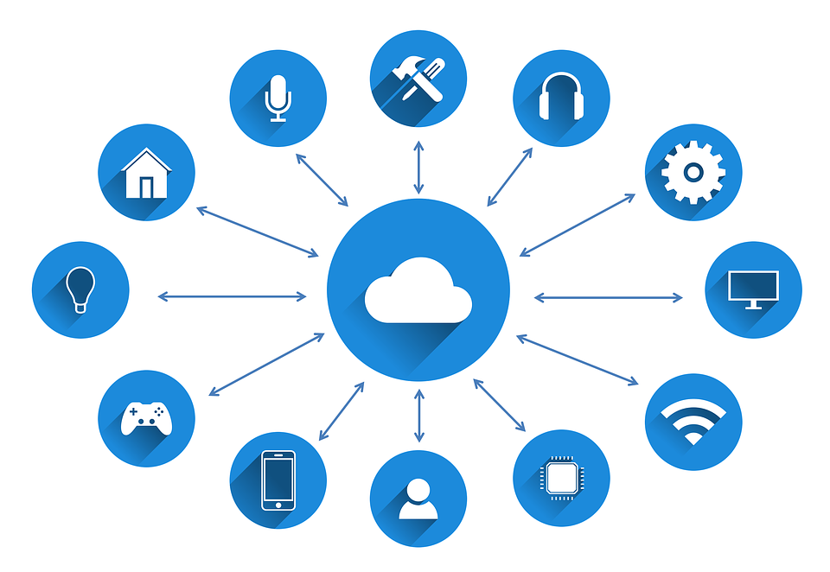

The internet has been around for a while, but it’s been the product of people. So all the data, images, recordings, books were created by people and for the people. It is like a digital fabric instilled in our lives in one way or another. However, there is an emergence of the new Internet which is poised to change the world. The new internet is not just about connecting people, it’s about connecting things, and hence it’s named the Internet of Things.

But connecting things to the internet is a big deal right? Here’s why!

Things start to share their experiences with other things. Now you might be asking how is that work?

You take things, and you add the ability to sense, communicate, touch and control, and then you get an opportunity for things to interact and collaborate with other things. We, as human beings, interact and contribute and collaborate with other people in our environment through our five senses. Now, imagine if things with the ability of touch and communicate and that’s where the internet of people intersects with the internet of things.

IoT is the network of devices, and other items embedded with electronics, software, sensors, actuators, and network connectivity which enable these objects to collect and exchange data.

**A story exemplifying how big the Internet of Things is**



In 2007, a bridge collapsed in Minnesota, which killed thousands of people because of the steel plates inadequate to handle the bridge’s load. When we rebuild bridges, we can use smart cement, i.e., cement integrated with sensors to track stresses, cracks, etc. This cement could alert us to fix problems before they cause a catastrophe.

However, these techniques are not only limited to the bridge’s structure. The same sensors in the concrete would detect ice on it and communicate the information via the wireless internet to your car. Once your car knows there is a hazard ahead, it will instruct the driver to slow down, and if the driver doesn’t, then the car will automatically slow down for him. It’s just one of the ways between devices to communicate.

**Why we should adapt to IoT?**

The number of devices has increased exponentially over the last decade and is expected to rise further in the coming years. It is projected to reach 50 billion by 2020. Now based on the number of people living on the planet, that ratio of devices to people is vast, and it would only bring growth in different sectors of life.

The enormous potential that the data carries could be unmasked using the advanced tools and technologies that have evolved over the years. It could lead to groundbreaking achievements in the field of healthcare, IT, automobiles and others. The ability of IoT to sense and communicate through the knowledge of data would help in preventing various natural calamities before it even occurs.

But how the data could be unmasked?

The tons of data that are getting generated these days has hidden patterns which would lead to specific predictions using the advanced Machine Learning and Artificial Intelligence tools. Those patterns would help the system learn and identify the possible outcomes based on the new data and provide the appropriate solution based on the domain one is working.

**Advantages of IoT**

* IoT network benefits not one but all that is individual, society, stakeholders of the business, etc. because IoT saves time and money.
* IoT delivers faster and accurately with minimum utilization of energy which improves the quality of life.
* It is used for patient monitoring by installing various types of wireless sensors on the patient body which communicates with the IoT network and provides all the required information of patient under treatment.
* IoT is used in the security of home devices which are monitored and controlled either locally or remotely using easy-to-use applications available on smartphones.
* IoT used in asset and individual tracking, inventory control, energy conservation, shipping, etc.
* It has applications beyond only machine-to-machine communication.
* IoT communicate themselves to its owner indicating its location and conditions.
* The industry also uses IoT to increase efficiency in the supply chain and increase productivity by connecting all source of data.
* IoT helps farmers by providing information regarding weather forecast, research related to soil, advanced techniques of food production, etc.
* By installing sensors in a city, citizens can manage free parking, feel more secure, etc.

**Threats to the Internet of Things**

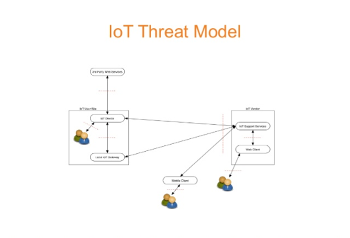

The IoT has simplified our lives and solved many real-life problems in the process. However, there are pitfalls, challenges, and blind-spots in the internet of things.

As the number of objects and devices connected to the internet seem to rise exponentially, so does the threats surrounding it. Our devices are built on specific infrastructure which is vulnerable and could easily be hacked if proper measures are not taken.

The wireless connections incorporated within these devices pose security threats which are getting more complicated as we further enter into the field of advanced technology.

The most prominent example of threats caused by the Internet of Things is the Wi-Fi connection at home which is connected to a smart-hub. Those smart-hubs could be hacked and filtered with trojans which could snatch away critical information from our system. Wi-Fi hacking is one of the most common problems that are being faced these days.

The lack of security in our smart devices often allows criminals to track our location and even hack into our security cameras to monitor our daily activities. It only jeopardizes our daily lives but leads to a significant concern of safety in our day to day lives as well.

**Latest News**

* The total number of connected devices will reach 27 billion by the end of 2019.
* 5G networks will become a backbone for internet of things in the near future.

For more news, follow - <https://www.iottechnews.com/>